**TAKING PRIDE AND MAKING STRIDES IN THE WORKPLACE**

**Labour relations agency and panel of leading speakers join our first official Pride event, Encouraging Respectful Relationships in The Workplace.**

The Labour Relations Agency brought together speakers from a variety of backgrounds and perspectives to stage our first Pride Panel, adding the voices of lived experiences to the guidance which we have produced.

The LRA have taken a leading role in providing vital guidance, support and advice to employers to promote good employment practice within Northern Ireland and ensure Equality, Diversity and Inclusion forms part of the fabric of their businesses.

As part of that work, we have recently produced a guide and podcast on this subject which embraces all aspects of diversity and inclusion, encouraging organisations and their staff to create a harmonious workplace where all can feel welcome and included.

The event was introduced by one of our Employee Relations Managers and Chair of our LGBTQ+ and Allies Staff Network group, Patrick Quigley, who initiated the LRA’s first participation in 2023’s Pride event.

He was joined by Jude Copeland from Cleaver Fulton Rankin who brought his extensive experience of working with a range of LGBTQIA+ and other charities to chair the discussion.

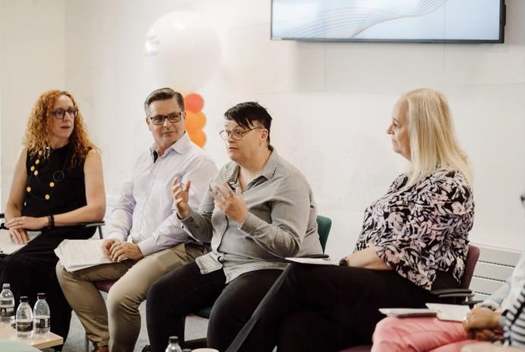

**Talking inclusivity in the workplace: Pride panellists** Our Pride Panel event presented engaging and enlightening views and experiences shared by our panellists, Morna Blaney from the Labour Relations Agency, Orla McKeating from Diversity Mark, Paul Gillen, partner at Lewis

Silken Solicitors, Geraldine Alexander a Senior Trade Union Official with NIPSA,

Kirsten Kearney from Inclusive Faith, Karen McShane – Business owner and

International President of the Chartered Institute of Highways and Transportation, and Tara Kelly EDI Outreach Manager from NIHE.

Patrick Quigley launched the discussions by reflecting on how occasions such as Pride remind us that that not all people have a positive experience in their place of work, with many of the LGBTQIA+ community unwilling or unable to be their authentic selves for fear of discrimination or harassment.

He added that the Pride Panel aimed to encourage open conversations in the workplace with many people and employers still fearful about what have previously been regarded as sensitive or taboo subjects, including issues affecting LGBTQIA+, but the avoidance of a subject for fear of causing offence can be isolating and can add to the sense of not feeling included.

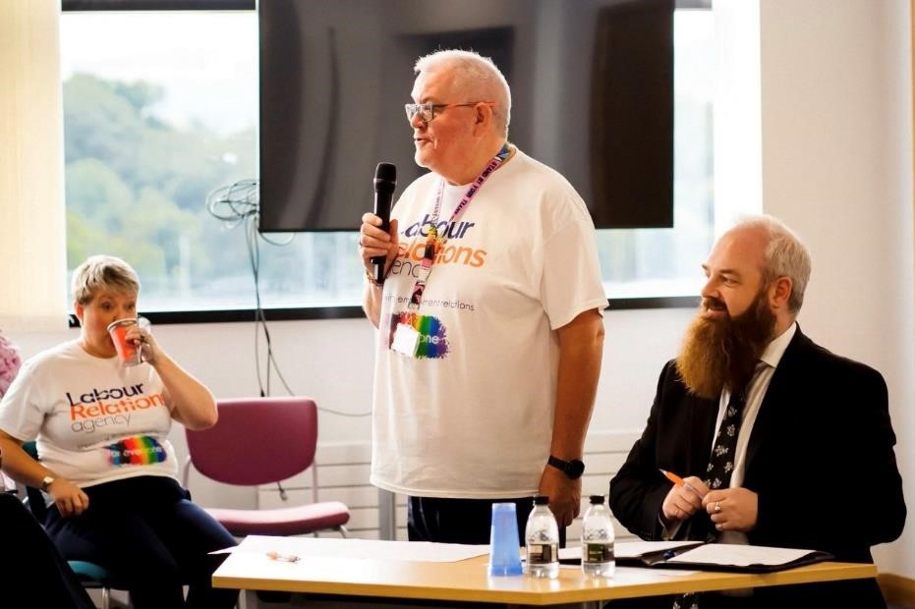

**Encouraging open conversation: Patrick Quigley Chair of our LGBTQ+ and Allies Staff Network group**

By staging the Panel, employers were encouraged to open these conversations in their own place of work and share the benefits of inclusivity not just for the wellbeing of individual members of staff, but also for businesses and organisations.

Panel Chair, Jude Copeland, from Cleaver Fulton Rankin, reflected on the LRA guidance on encouraging respectful conversations in the workplace and how it provides vital tools and advice: “It doesn’t cost money to have respectful conversations,” he explained. Our guidance is useful for LGBTQIA+ issues as the workplace are where people should feel secure physically and psychologically.” Morna Blaney, from the LRA encouraged employers to have the confidence and the tools to improve inclusivity “This is about managers or employees having the vulnerability and courage to start a conversation,” she said. “And allowing work to be a safe space for those conversations.”

Tara Kelly EDI Outreach Manager from NIHE, highlighted the benefits to business in getting involved with PRIDE. “It demonstrates that the organisation values who you are as a person,” she explained: “It attracts new people to the organisation, and it promotes inclusion to customers.

She added: “It is important for Pride to be authentic and there is power in employers and retail putting out flags and engaging with LGBTQIA+ staff. Small organisations are still able to deliver a meaningful contribution to Pride by keeping it simple with a clear simple message.

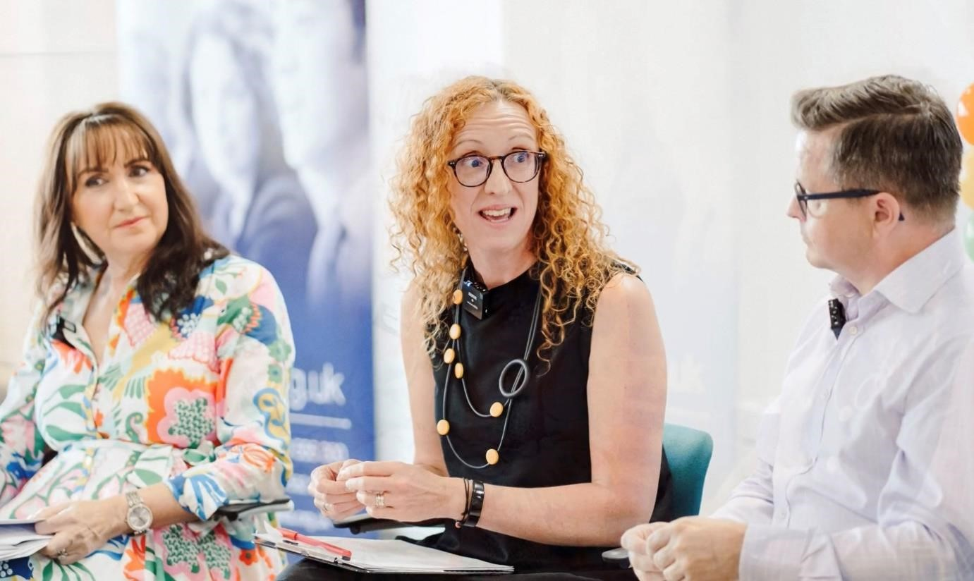

Karen McShane – Business owner and International President of the Chartered Institute of Highways and Transportation, spoke of the importance of ‘Creating an open culture and psychologically safe space in the workplace.’

She stressed: “It is essential that employers listen to what employees say, have regular meetings and a no blame culture as well as talking openly and listening carefully. Put mechanisms in place to support staff to be their true authentic selves.”

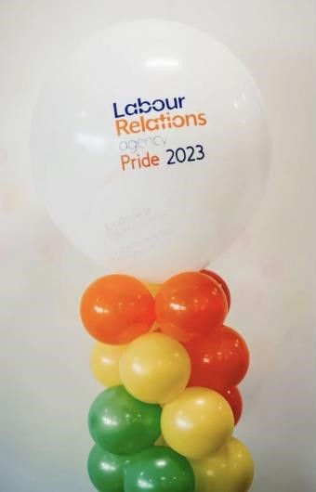Dr Kirsten Kearney, from Inclusive Faith, reflected on the significant challenges that must be faced in reducing hostilities amongst the faith community in Northern Ireland: “There is a lot of fear in Northern Ireland from the faith community about PRIDE,” she said. “It is important to dismantle prejudices, and to continue encouraging respectful conversations.”

Geraldine Alexander, a Senior Trade Union Official with NIPSA, highlighted the support from Trade Unions in building an inclusive culture.

She reflected on research published by the TUC on progress for the LGBTQIA+ community in inclusion. “Despite LGBTQIA+ people having protection of equality legislation, many are still experiencing a negative and harmful environment and therefore have low expectations as to how they are treated at work,” she explained.

“Let’s remember the past by honouring the future and stamp out discrimination, harassment and bullying.”

Orla McKeating, from Diversity Mark, highlighted the business case for inclusion and the support tools that the organisation provides to empower organisations in their journey and build allyship and show up for marginalised people: “It’s the right thing to do to allow people to show up as their true authentic self, and to feel heard, seen, supported and valued.

Paul Gillen, partner at of Lewis Silken Solicitors, presented insights into the challenges that employers face: “Traditionally workplaces were encouraged to have conversations about neutral topics but now there is a focus on a harmonious environment, where everyone’s view is respected, he said.

“However, this is challenging for employers to deal with competing rights.”

Paul expressed the importance of people feeling free to be visible in their beliefs. For employers, it is important that they have policies are in place and that these are reviewed to check they are fit for purpose and to determine when people cross the boundary.

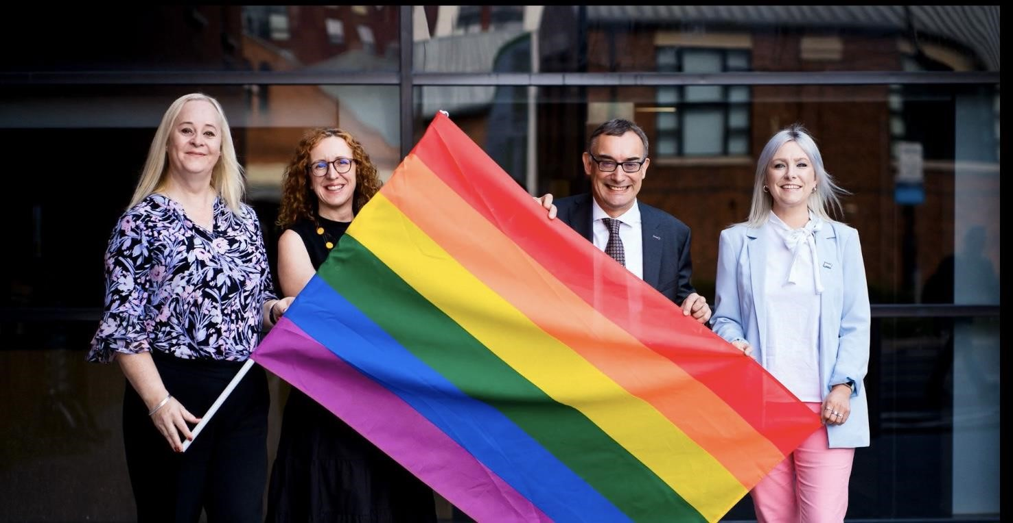

The Labour Relations Agency wish to thank all our panel members who took part and gave vital insights, advice and engaged in empowering discussions that ensured our first Pride Panel was a huge success.



# Pride Panel Feedback: What our attendees said

*“The selection on panellists each brought their own perspective. I particularly liked the*

*representation on LGBTQIA+ people with faith.*

*This is something often overlooked, and I wish to adopt in my own organisation.”*

*“Well organised and very engaging”*

*“I was impressed to see LRA approach this subject – It’s very timely and something that*

*organisations have avoided due to politicalisation of the issue. Thank you!”*

*“It was a fantastic event, great panel of speakers and well done to the LRA for hosting a great event.”*

*“Great practical advice. Very informative and interesting discussions.”*

# Visit our online resources

[LRA EQUITY, DIVERSITY AND INCLUSION STRATEGY TO 2025](https://www.lra.org.uk/resources/edi-strategy/equity-diversity-and-inclusion-strategy-2025)

[RESPECTFUL CONVERSATIONS IN THE WORKPLACE PODCAST AND GUIDE](https://www.lra.org.uk/resources/guide/respectful-conversations-podcast-and-guide)